**SIMATS ENGINEERING**

**SAVEETHA INSTITUTE OF MEDICAL AND TECHNICAL SCIENCES**

**CAPSTONE PROJECT REPORT**

**ON**

**Creating an SMS-controlled smart notice board as an NLP project introduces students to a combination of natural language processing (NLP), wireless communication, and embedded systems.**

**Submitted**

**by**

**Name – Thanigaivelu Yogesh (192211330)**

**Jayasurya K (192211342)**

**Subject – CSA1355 – Theory of Computation with Finite Automata.**

**ABSTRACT**

The e-notice boards have several applications which are used in various sectors such as shopping malls, educational institutes, traffic control, banks and public addressing system (PAS) etc. The old wired e-notice board is controlled by microcontroller. The microcontroller contains the program code to show the message on display. To change message on display, it needs to change microcontroller program code again. All these processes are generally hardwired and complex. By adding GSM wireless communication interface to this system, we can make smart e–notice board to overcome these limitations. So, we have interfaced GSM Modem with microcontroller and implemented a SMS transmission and reception technique. The message on display is easily changed by sending SMS to it. This paper explains development of SMS controlled smart e-notice board.

**INTRODUCTION**

Now days the e-notice boards are observed at several locations such as shopping malls, educational institutes, traffic control, banks, stoke exchanges etc. These e-notice boards are designed according to customer’s requirement. In all these e-notice board the displayed messages are fixed and they are programmed in controller. But in these displays if someone want to change the message, they have to go there and connect the display with PC/Laptop to update the program inside the microcontroller with new code. So the message change process becomes complex. Therefore, to overcome these limitations we have developed smart e-notice board which is remotely controlled using GSM (Global System for Mobile Communication) technology. We have selected GSM technique because it is one of the fastest growing telecommunication technologies of the world. Even today millions of users are using different mobile networks in the world.

**DESCRIPTION OF THE BLOCK DIAGRAM**

A smart e-notice board is designed with GSM Modem SIMCON SIM 300, microcontrollers P89V51RD2, MAX232 chip and 16×2 LCD (Liquid Crystal Display). 16×2 (16 characters, 2 lines) LCD panel is used to display message. The GSM Modem SIM 300 is interfaced with microcontrollers P89V51RD2 via MAX232 chip. Microcontroller communicates with GSM modem using serial communication standard RS232. A microcontroller sends AT commands to GSM modem to send and receive SMS. SMS (Short Message Service) is a text messaging service that most widely used for the exchange of short text messages from mobile phone devices. This service enables us to send and receive short messages of 160 characters with cellular phone. Microcontroller reads the message from SIM (Subscriber Identity Module) card of GSM Modem and displays it on LCD. Figure 1 shows the block diagram of developed SMS controlled smart e-notice board.

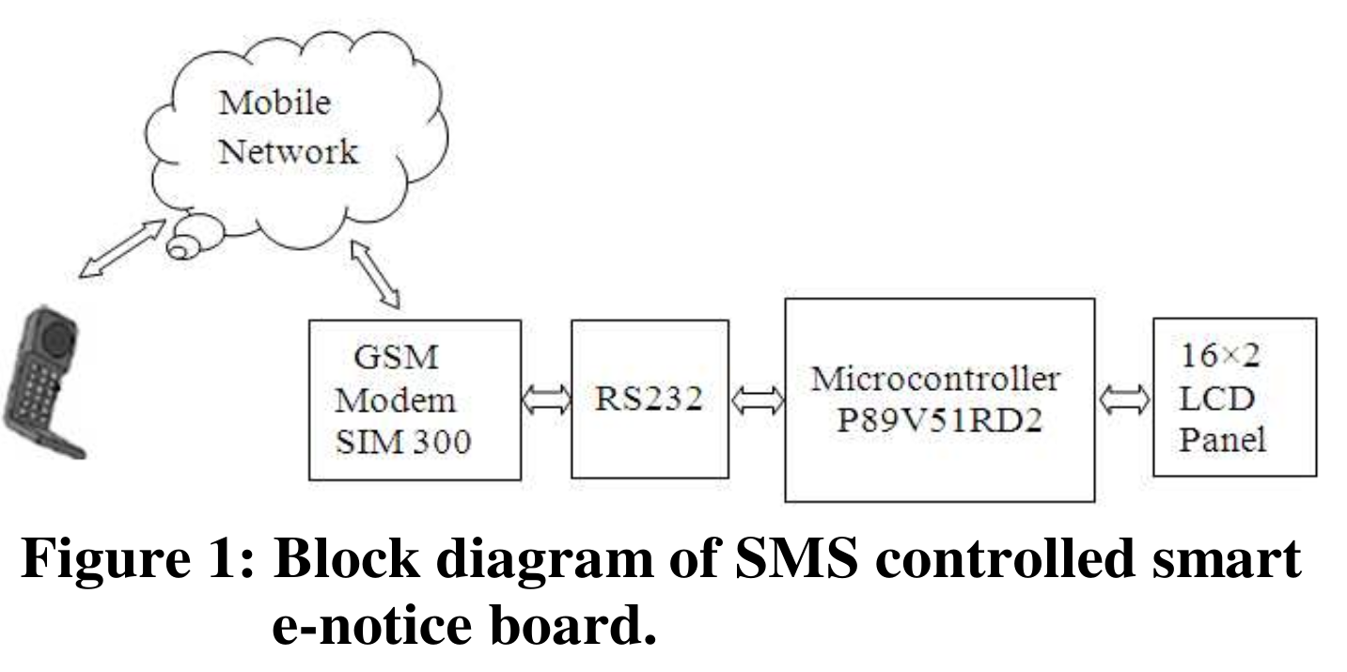

**89V51RD2 serial communication**

The P89V51RD2 is a 40-pin flash-based 8-bit microcontroller. It runs with a 11.0592 MHz external clock. The chip has up to 64 kB FLASH Program Memory, 1024 bytes of data RAM. The microcontroller P89V51RD2 has a USART (Universal Synchronous Asynchronous Receiver Transmitter), which can be configure into synchronous and asynchronous operating mode. In microcontroller some pins and registers are specifically designed for serial communication. The two pins TXD and RXD are used for transmit and receive data serially.

The USART of the 89V51RD2 is configured using SCON register. The SBUF register are used for store data while transmitting and receiving data. Data is usually transmitted in 8-bit words. In the GSM modem interfacing standard non-return-to zero (NRZ) format (one START bit, eight data bits, and one STOP bit) is used. The TXD and RXD pins are part of port 3 and TTL compatible. [1] So the IC MAX232 is used to converts TTL signal into RS232signal. Standard baud rate 9600 is selected for communication.

**RS232 Standard**

The interfacing standard for serial communication was set by Electronics Industries Association (EIA) in 1960. In RS232 standard a bit 1 is represented by -3 to -25V, while bit 0 is by +3 to +25V. This is the device convert TTL/RS232 or vice versa. The MAX 232 chip converts TTL voltage levels of the microcontroller 89V51RD2 into RS232 signal level. The IC MAX232 has 2 set of line driver for transmitting and receiving data. The MAX232 and microcontroller P89V51RD2 shares same supply voltage.

**Liquid Crystal Display (LCD):**

The LCD (16×2) panel is a standard 2 lines of 16 characters. Each character is of 5×7 pixels. It has 16 pin. Pins D0-D7 are used as data inputs and pins RS, R/W and E are used as control signal. The RS (Register Select) input pin defines two modes, RS = 0 selects command mode, RS = 1 data mode. The RW (Read/Write) line used to select write mode and read mode. It can be made low for write mode and high for read mode. The data on data pins D0-D7 is latched in LCD by the pulsation on the E (Enable) input. The LCD panel itself contains a microcontroller. The LCD requires ASCII codes of each character to be display on it. It can be initialized according to the data and display options required.

**GSM Modem**

This module provides serial RS232 interface for easy serial communication. It has optionally available USB interface for easy interface to laptops, computers, etc. Three LEDs for Power, RING and Network indication are available on board for easy debugging. It can be controlled through standard AT commands. Onboard buzzer is available for general audio indication. Onboard 3V Lithium Battery holder with appropriate circuitry provides backup for the internal RTC module. It has onboard wire antenna for better reception. It allows an adjustable serial baud rate from 1200 to 115200 bps. It operates on voltage: 7 – 15V DC.

**Subscriber Identity Module (SIM)**

The Subscriber Identity Module is commonly known as a SIM card. It is a detachable smart card containing the user's subscription information and phone book. The user can change operators simply by changing the SIM. A SIM card contains international mobile subscriber identity (IMSI), security authentication; temporary information related to the local network and a list of the services for user. It has two passwords: a personal identification number (PIN) for ordinary use and a personal unblocking code (PUK) for PIN unlocking.

**Power supply**

The microcontroller and other devices get power supply from AC to DC adapter. The adapter output voltage is 12V DC non-regulated. The 7812/7805 voltage regulators are used to convert 12 V to regulated 12V/5V DC.

**Working of SMS Based Smart e-Notice Board**

The microcontroller communicates to GSM modem using GSM 07.07 protocol. In this smart e-notice board a low cost GSM modem SIM300 has been connected to the P89V51RD2 serial port via its data cable and a MAX232 voltage converter IC. The smart e-notice board main program is written using embedded „C‟ Language and which is compiled using Keil compiler Ver.3. The main program initializes LCD and continuously displays a welcome message on it. After reception of new SMS, microcontroller executes SMS read subroutine. In SMS read subroutine microcontroller sends AT commands to GSM modem to read senders mobile number and message. If SMS is received from authentic sender, microcontroller saves it into memory and displays it on the LCD panel, otherwise microcontroller keeps displaying previous message. Also microcontroller sends acknowledge SMS to authentic sender.

**Software**

Program code for SMS based wireless notice board is developed using Keil development tool. Keil provides broad range of libraries, IDE (Integrated Development Environment), assemblers and linkers.[6] The program code for this system is written in Embedded-C language. The Hex file generated after compilation of code is shift into microcontroller P89V51RD2 using flash magic software. Software is based on flowchart shown in figure 2.

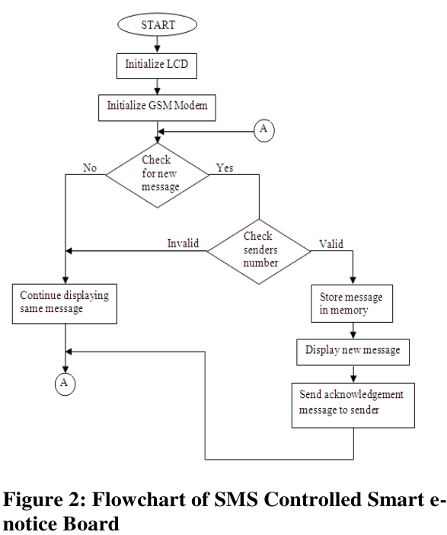

**AT commands**

Every GSM modem is controlled with AT commands. AT commands are known as “Attention Terminal” or "Attention Telephone“. The commands are sent to the GSM modem. These commands are used for operations that are usually done from the keypad, such as calling a number, sending, reading, or deleting an SMS. [7] Some common AT commands are given in Table.1

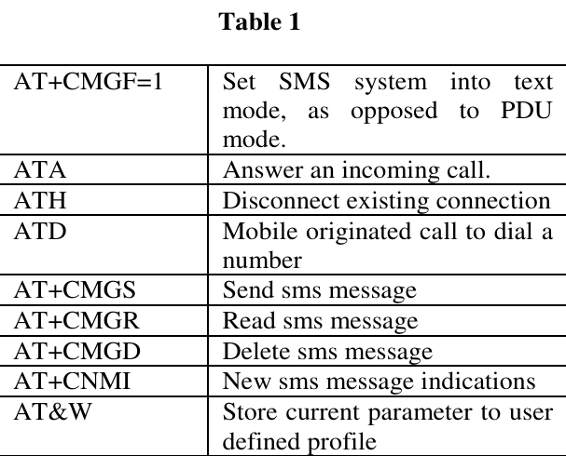

**TESTING & RESULT**

The whole system has been designed and developed based on the flowchart shown in figure 2. The designed system has been tested successfully. The microcontroller issues some AT commands to initialize GSM modem SIM300. It also initializes the LCD panel. Then Microcontroller displays a welcome message on smart e-notice board. The microcontroller checks for new message. If new SMS is received from authenticated sender, then the microcontroller generates the “Acknowledgement SMS” which it sends to the authenticated cell number. Then Microcontroller decodes the message and displays it on the LCD panel. A complete working SMS Based Smart e-Notice Board is shown in figure 3.

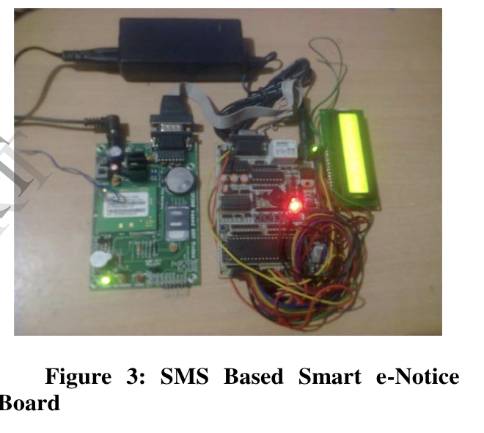

**Future Development**

The large LED scrolling display can replace small LCD panel. Multiple messages can be displayed at a time. Wireless LED scrolling display can be set up at public transport place such as bus station, railway station, and airport.

**Conclusion**

The SMS based smart e-notice board is efficiently designed. The smart e-notice board system accepts new SMS, validate it, store it and display it on 16×2LCD panel. It also sends acknowledge SMS to senders mobile. It reduces the overall development cost and also minimizes the complexity. Therefore smart enotice board system becomes smarter, efficient and portable.

**References**

[1] The 8051 Microcontroller and Embedded Systems, Muhammad Ali Mazidi, Janice Gillispie Mazidi, Prentice-Hall of India Pvt. Ltd., India. Page187-191.

[2] http://www.engineersgarage.com/electronic- components/16x2-lcd-module-datasheet

[3] SIM300 Hardware Interface Description. Dec 27, 2005, http://www.probots.co.in/Manuals/SIM300.pdf

[4] www.mpf.org.in/pdf/technology/SIM_Card Commi ttee_Report.pdf

[5] GSM 07.05 TECHNICAL SPECIFICATION, January 1998,Ver 5.5.0, www.ctiforum. com/ standard/standard/etsi accessed on 30 September, 2008

[6]http://8051-projects-tutorials.blogspot.in/2013/ 06/Keil-uvision-4-guide.html

[7]AT Commands Reference Guide, http://www.telit. com/ module/infopool/download.php?id=542.